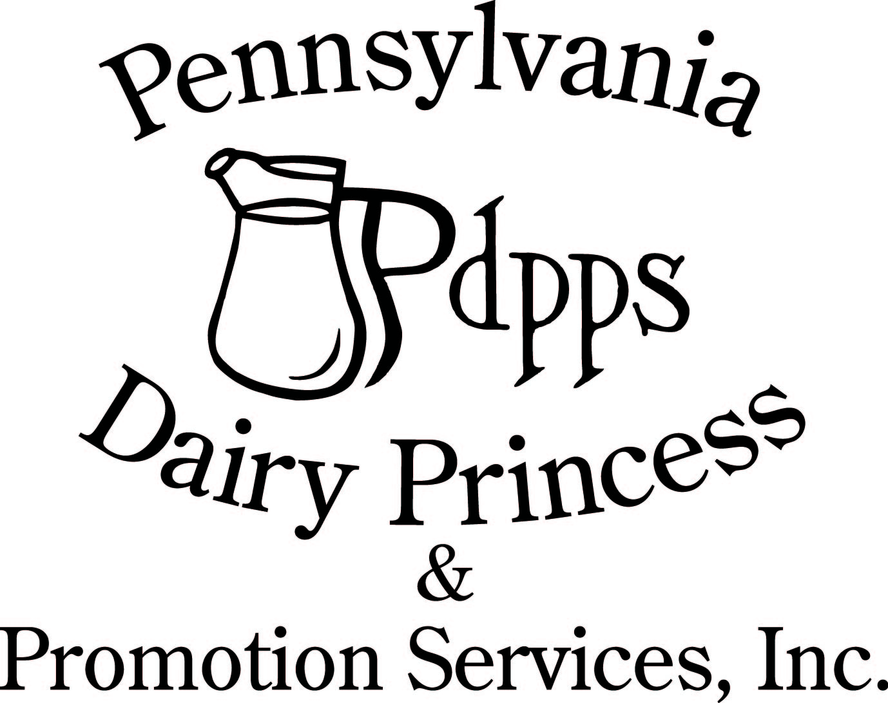
PO Box 177 Ph. (717) 599-4363
Laurelton PA 17835 www.padairy.org

August 9, 2024

To Whom It May Concern:

Please excuse ________________________________________ on September 19 & 20, 2024. _______________________ ___________________________ will be representing and promoting the dairy industry at the 68th annual Pennsylvania Dairy Princess Competition where she will be recognized for her service to the dairy industry and compete for the title of Pennsylvania State Dairy Princess.

The Pennsylvania Dairy Princess Program provides each county Dairy Princess with unique and invaluable educational experiences. During her reigning year, each Dairy Princess will attend workshops and seminars to learn about public speaking, communicating with consumers and presenting herself professionally. She will promote the dairy industry by giving speeches, visiting schools, writing articles and conversing with members of the public to speak on behalf of the dairy industry. She will not only serve Pennsylvania’s number one agricultural industry- dairy, but will also develop the life and leadership skills she will need to become an agricultural leader of tomorrow.

Please also keep in mind that Senate Bill 485, Act 35, of 2001 changed the Public School Code to require school boards in Pennsylvania to adopt policies permitting students to be excused from school in order to participate in educational agricultural experiences such as those at Pennsylvania-sponsored fairs and shows.

I appreciate your understanding and cooperation in excusing __________________________ on September 19 and 20, 2024. If you have any questions, please contact me at (814) 644-8814 or via e-mail at carrie@padairy.org.

Sincerely,
Carrie Anderson
Program Director
Pennsylvania Dairy Princess & Promotion Services, Inc. (PDPPS, Inc.)

