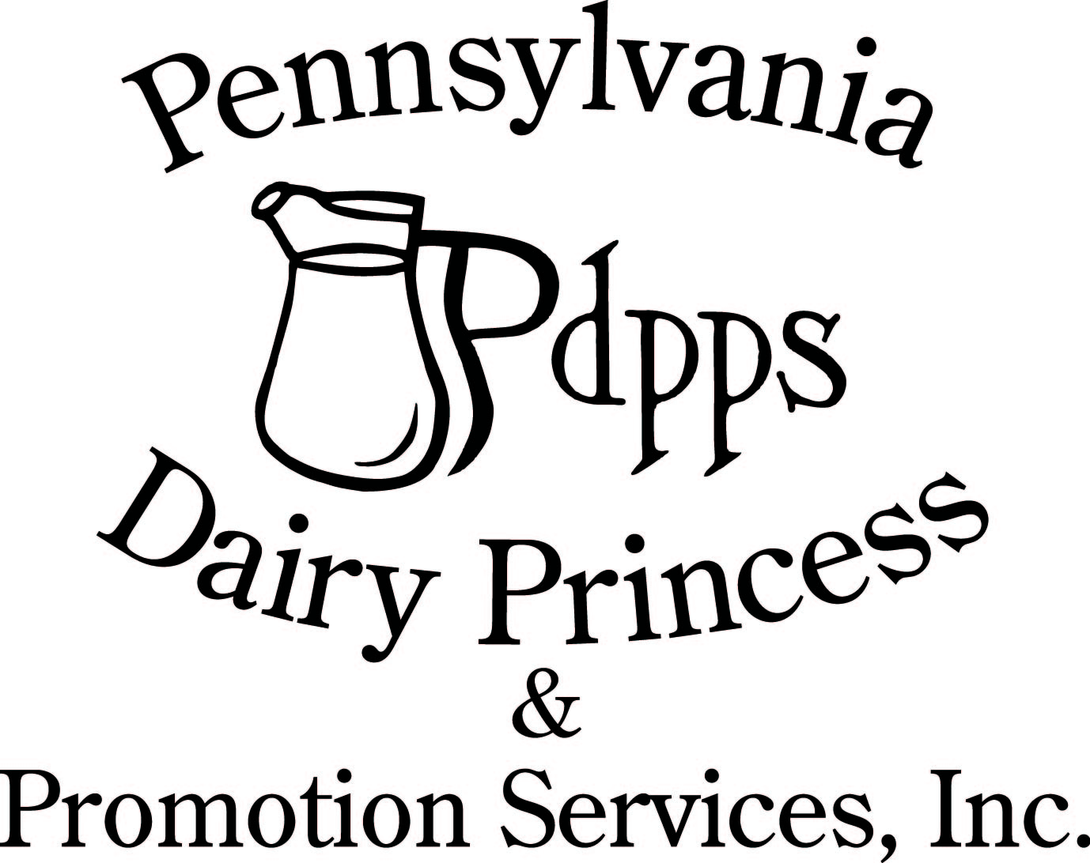
PO Box 177 Ph. (717) 599-4363
Laurelton PA 17835 www.padairy.org

2024 Pennsylvania Dairy Princess Competition
Check-in Sheet

Speech Contest

Name:______________________________ County: ________________________

Complete form and submit it at registration on Thursday, September 19, 2024

Speech Contest:

My Speech Title is: ___________________________________________________________________

My Speech answers the speech prompt number (page 23 of the handbook): ___________

My audience is: ____________________________________________ (example: high school students)

You MUST bring these forms and all required attachments (if applicable) with you to registration on Thursday, September 19, 2024.
Presentation (Skit) Contest

Name: __________________________ County: __________________________

Presentation Title: _______________________________________________________

Circle the age group your presentation is geared for:

- Preschool
- Elementary School
- Middle School
- High School
- Adults

Please draw a diagram below of how you would like our stage hands to set up props for your presentation (You will not be setting your props up).

You MUST bring these forms with you to registration on Thursday, September 19, 2024.

