2025 Sash and Crown Order Form
County: _________________________ Shipping Info:
Person placing order: ______________________ Ship to: _____________________________________
Pageant Date: ___________________________ Phone: ____________________________________
Phone: _________________________________ Address: ____________________________________
Email: _________________________________ THIS ORDER FORM IS YOUR INVOICE
Please return this form by March 30th or May 1st with a check payable to:
PDPPS --- PO Box 177 Laurelton, PA 17835

NOTE: Orders will not be mailed until your payment is received and outstanding invoices are paid. NO EXCEPTIONS. This order form is your invoice; a $30.00 fee will be assessed for each additional invoice that needs to be sent.
Type | # Needed | Description |  |  | Price | Total Cost
Comp. Items |  | Complimentary Princess Sash |  |  | $35.00 | COMP
Comp. Items |  | Complimentary Princess Crown |  |  | $35.00 | COMP
Comp. Items |  | Complimentary Alternate Sash |  |  | $16.00 | COMP
Comp. Items |  | Complimentary Alternate Crown |  |  | $10.00 | COMP
Lapel Pin |  | Silver Small Rhinestone Cow Head Pin |  |  | $22.00
Lapel Pin |  | Pewter Cow Lapel Pin |  |  | $9.00
Lapel Pin |  | Pewter Milk Carton Lapel Pin |  |  | $9.00
Lapel Pin |  | Got Milk Lapel Pin (limited supply - First come, first serve) |  |  | $6.00
Crowns |  | Princess Crown (2 3/4” high) |  |  | $35.00
Crowns |  | Alternate Crown (1 3/4” high) |  |  | $10.00
Crowns |  | Maid Crown (1 3/8” high) COUNTY ONLY |  |  | $9.00
Crowns |  | Lil’ Miss Crown (1 1/2” high) COUNTY ONLY |  |  | $9.00
Sashes |  | County Princess Sash with Rosette |  |  | $35.00
Sashes |  | County Alternate Sash with Rosette |  |  | $17.00
Sashes |  | Dairy Maid Sash with Rosette |  |  | $14.00
Sashes |  | Dairy Miss Sash with Rosette |  |  | $14.00
Sashes |  | Lil Dairy Miss Sash with Rosette |  |  | $14.00
Sashes |  | Dairy Darling Sash with Rosette |  |  | $14.00
Sashes |  | Dairy Ambassador Sash with Rosette |  |  | $14.00
Sashes |  | Male Dairy Ambassador Ribbon with Rosette |  |  | $9.00
Sashes |  | Extra Rosette |  |  | $3.00
 |  |  |  |  | Subtotal
 |  |  |  |  | Shipping  /Handling | +$5.00 by March 30  Otherwise + $10.00
 |  |  |  |  | Total Amount
Things to Note:
Counties will be provided with ONE complimentary princess sash, crown, alternate sash, and crown (Please indicate on the form you need them otherwise you will not receive them). You will be charged for any complimentary items ordered and not used.

The Sash and Crown Order Form also serves as your order invoice. Sash and Crown orders must be accompanied by a check and must be submitted no later than March 30th to qualify for county $5.00 shipping, otherwise they must be submitted by May 1st and you must pay $10.00 shipping. If payment is not received with your Sash and Crown order form, you will not receive your order until payment is received. A $30.00 fee will be assessed for each additional invoice sent.

Counties must submit online to PDPPS yearly committee information. Incentive award checks (and any checkoff money distribution) are mailed directly to county Treasurers following State Competition if we have up to date information. Each county is responsible for having their own policy regarding the handling of the earned incentive monies. If a county has any outstanding invoices, their incentive check will be deducted the amount of the invoice, including any late fees assessed.

Orders will be shipped between March 25th and May 20th depending on your competition or coronation. If your sash & crown order needs to be mailed express, the county will be responsible for the additional shipping cost. Your sash & crown order will not be shipped until payment is received and outstanding invoices are paid. No exceptions!

Crowns
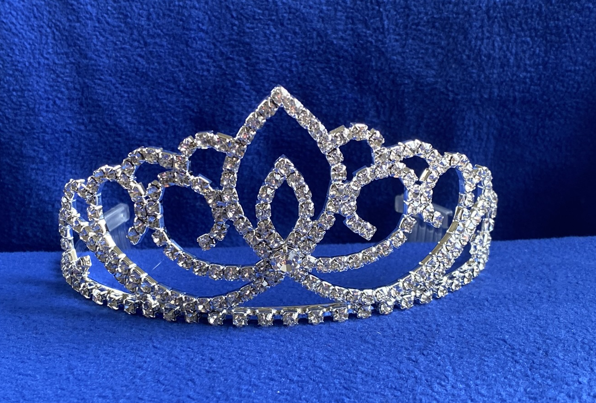
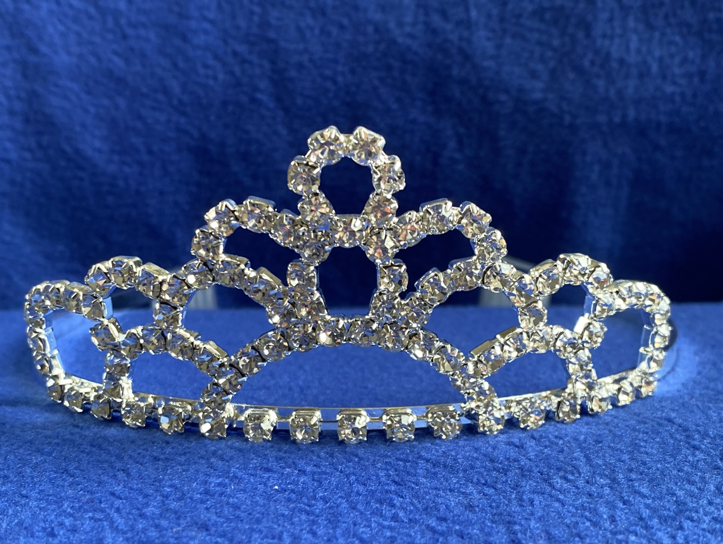
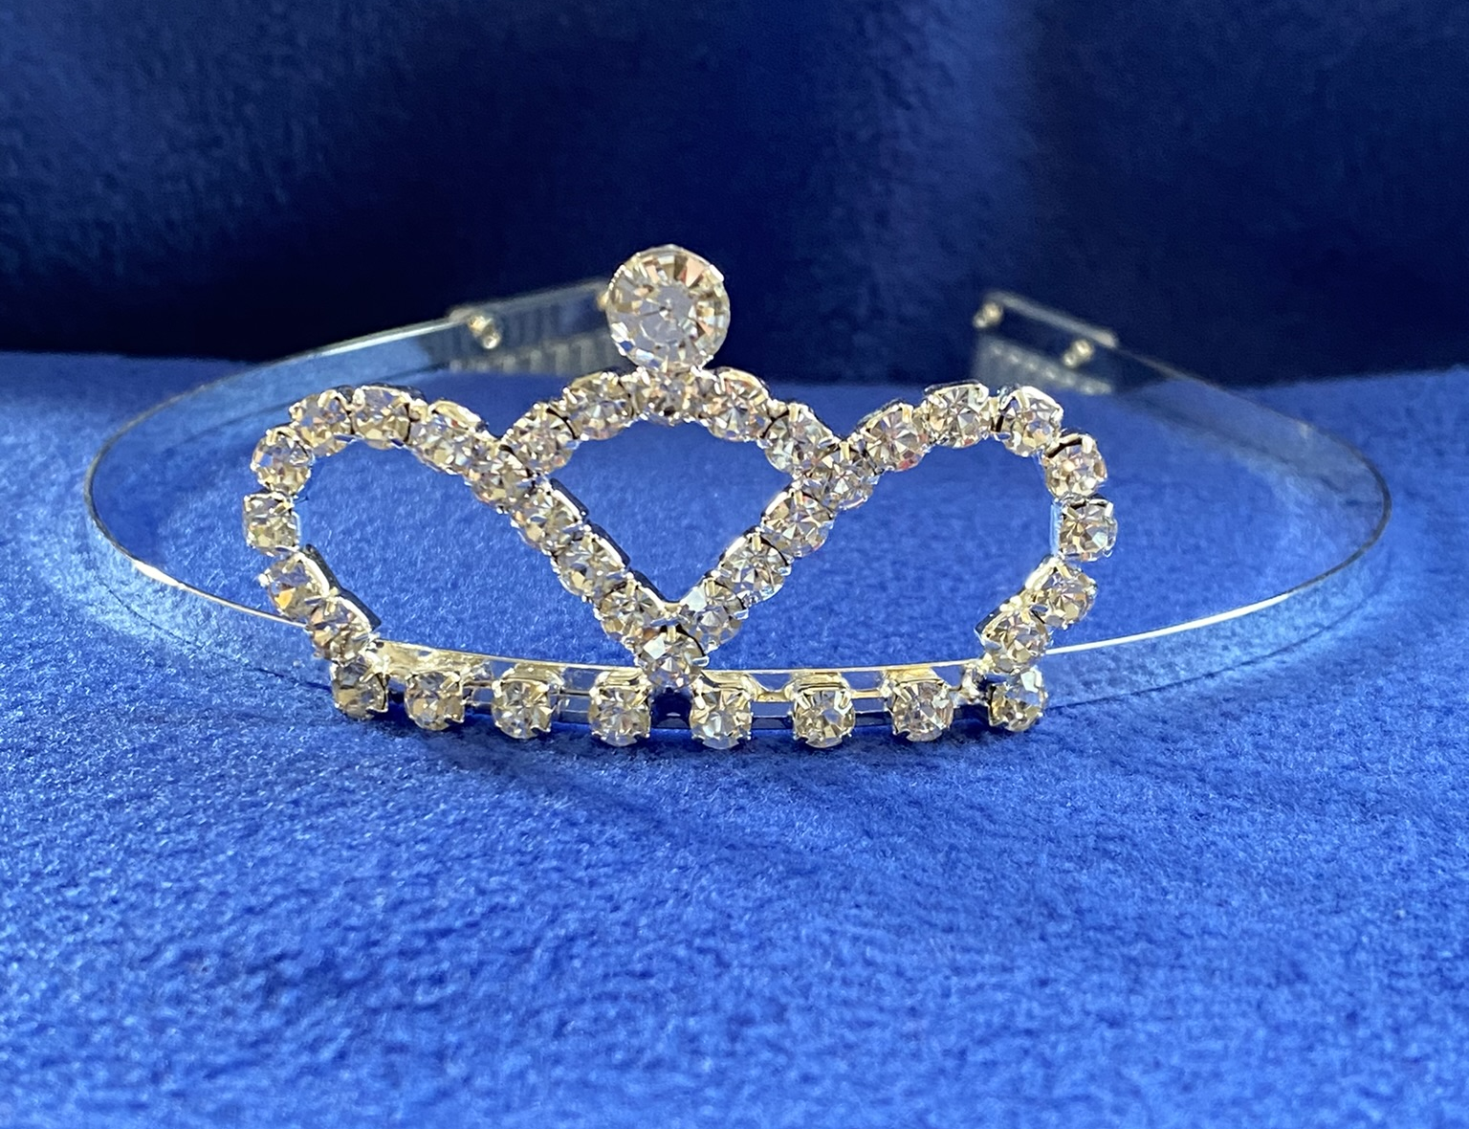
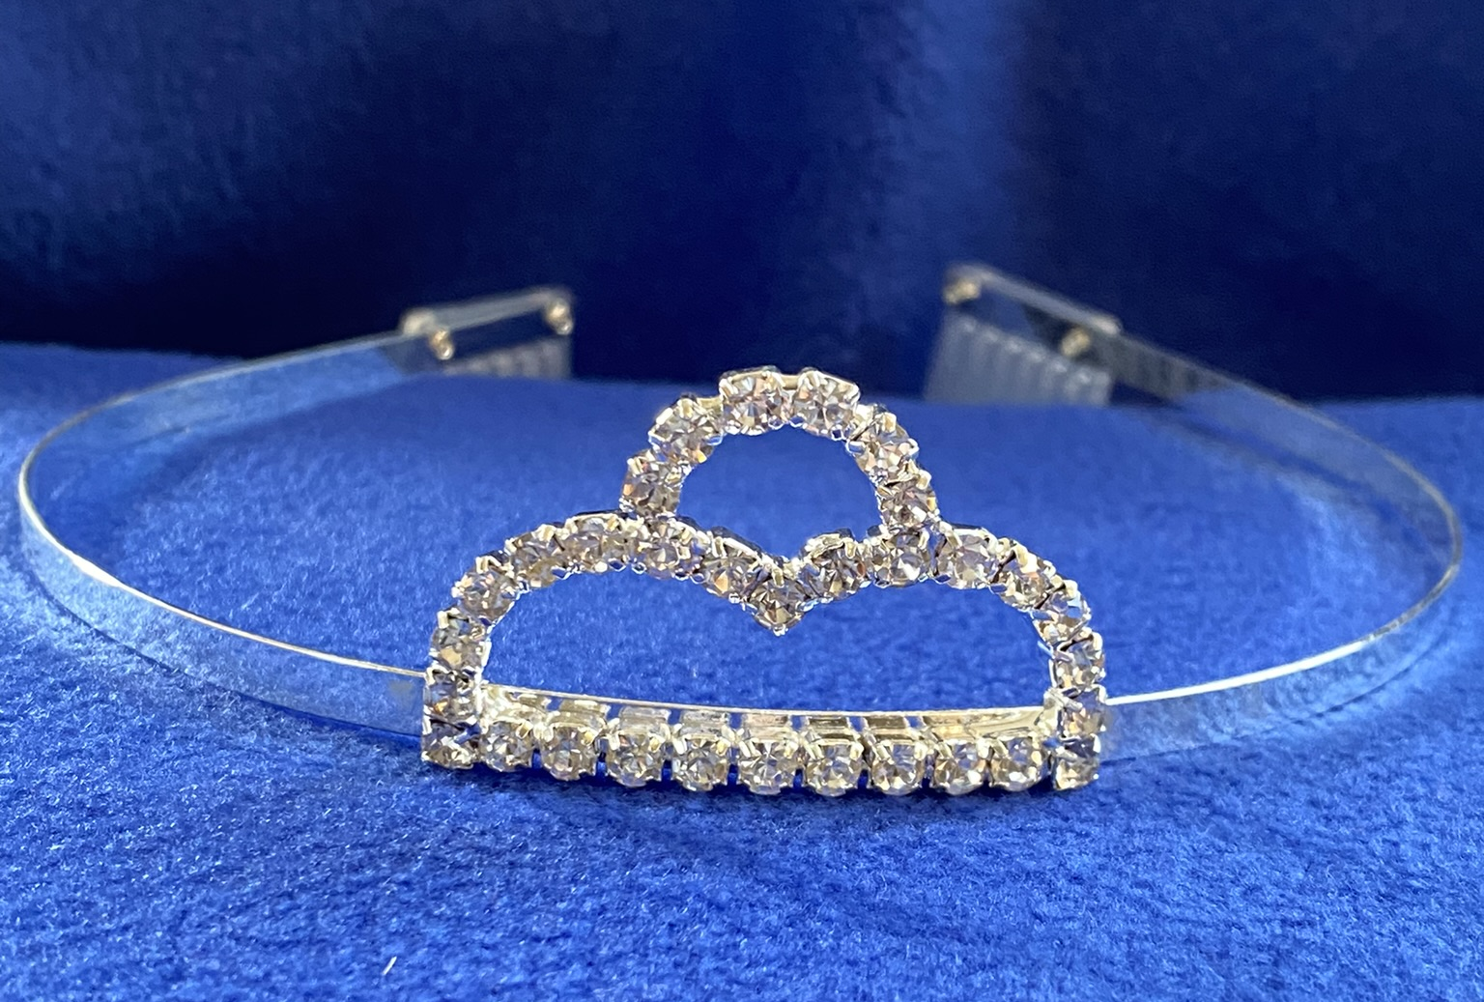

Princess Alternate Maid Li’l Miss

Lapel Pins
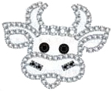
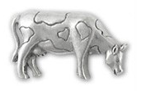
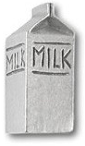
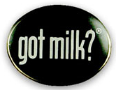

Small Silver
Rhinestone Cow Head Pewter Cow Pewter Milk Carton Got Milk (limited supply)
$22.00 $9.00 $9.00 $6.00

