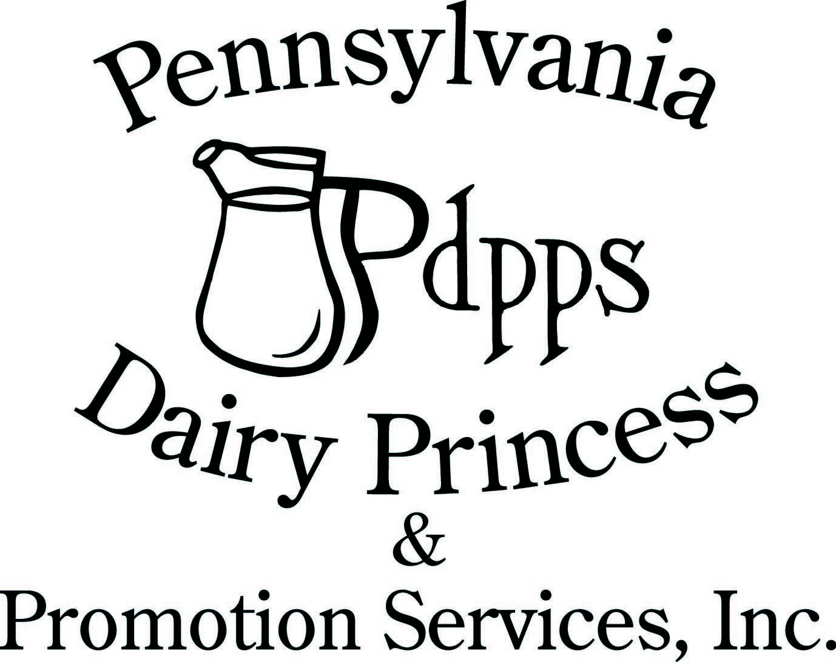
PO Box 177 Ph. (717) 599-4363

Laurelton PA 17835 www.padairy.org

January 30, 2025

Dear County Dairy Promotion Chairperson and Committees,

Greetings from PDPPS! As spring approaches, so does preparation for a new year in Dairy Promotion and we have an exciting year planned! Please take time to read this letter closely as there are many important dates and information included. Let’s start with training and leadership opportunities, all links for training are found at the bottom of this letter.

We will begin by hosting a virtual Spring Kickoff Meeting on March 8th from 10:00am to 12:00pm. You will need to register to attend. There will be two mini-seminar training sessions. One for Western PA (June 17) in Franklin and one for Eastern PA (June 18) in Middleburg. If there are royalty unable to attend, email your regional board members to let them know the names for excused board approval.

Our Dairy Princess Training Seminar will begin on Tuesday afternoon, July 8th at Roxbury Holiness Camp, Roxbury, PA and will conclude on the afternoon of Friday July 11th. There is a required $20.00 non-refundable deposit per attendee for the Dairy Princess Seminar. All other expenses for each princess/alternate and one chaperone will be covered. The 2025 State Competition will be at the Best Western Premier in Harrisburg from September 18th-20th. Our banquet luncheon & coronation will start at 1:00pm on Saturday. Links and information to come later.

For your convenience, we have highlighted in yellow the major changes in the 2025 Pennsylvania Dairy Princess Handbook. Each county chairperson received one copy. A gentle reminder to check out pages 37-41 for an additional $50.00 each month through Allied Milk Producers.

All Sash and Crown Orders with payment are due March 30 and no later than May 1st. Coronations can happen between April 1-May 31; however, please provide your order form AT LEAST 3 weeks in advance prior to your coronation.

PDPPS has a policy that only counties that have submitted an up-to-date roster will receive incentive money. Please be sure to complete the committee list form with all committee individuals including all royalty parents. You will need to complete a “new form” for each committee member. A link for the contact form is located below.

You will receive an e-mail with a copy of the submitted application. If the individual doesn’t receive a confirmation screen and an e-mail, the application WAS NOT submitted properly. All Princess applications will require three dairy recipes in Word or txt format only. These recipes will be used in the annual recipe book. As a county, if you would like to have a record of applications, you will need to ask your Princesses and Junior Royalty to print a copy for your records.

All princesses and junior royalty must complete the entire online application including medical information and handbook, photo release and dress code release section by June 1.

Online applications can be found at:

Web address: www.padairy.org - members only password fuelupwithdairy

Princesses:

https://form.jotform.com/padairy/2025-dairy-princess-app

Alternates:

https://form.jotform.com/padairy/2025-alternate-dairy-princess-app

Junior Promoters:

https://form.jotform.com/padairy/2025-junior-promoter-app

It is your responsibility to read, print (if needed), and complete all required documents.

Forms/Online Forms to Return:

- Virtual Spring Kickoff Meeting Registration

https://us02web.zoom.us/meeting/register/tZIocOmgqT8iG9PXvK-6iyxTV-FjgDT1M4T1

- County Competition/Coronation no later than April 30, 2025

https://form.jotform.com/padairy/2025-county-coronation-info

- Sash & Crown Orders (enclosed or on member’s only) No later than: March 30/May 1, 2025

- Volunteer Recognition Nominations No later than: April 1, 2025 (in handbook)

- Committee Contact Information No later than: May 31, 2025

https://form.jotform.com/padairy/2025-committee-contact-list

- County Royalty Team Listing No later than: May 31, 2025

https://form.jotform.com/padairy/2025-county-royalty-form

- County Seminar Reservation (Completed by Committee) No later than: May 31, 2025

https://form.jotform.com/padairy/2025-co-seminar-reservation-form

- Seminar Adult Attendee RSVP No later than: May 31, 2025

https://form.jotform.com/padairy/2025-seminar-adult-rsvp

- Mini-Seminar Attendee Training Reservations No later than: May 31, 2025

Must complete one registration for EACH attendee (including ALL adults)

https://form.jotform.com/padairy/2025-mini-seminar-registration

On behalf of all of us at PDPPS, thank you for your time and dedication to the dairy industry and helping to develop future leaders. As always, please let us know if we can help you or if you have suggestions to help with your programming.

All the best,

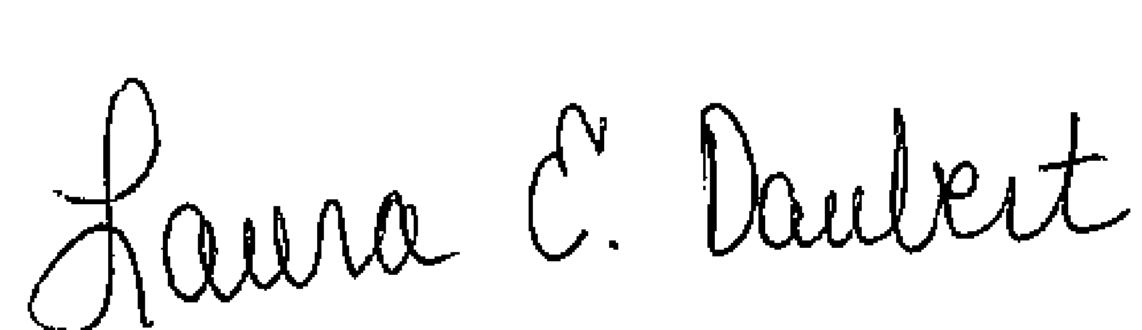

Laura E. Daubert Carrie M. Anderson

PDPPS Administrative Director PDPPS Program Director

