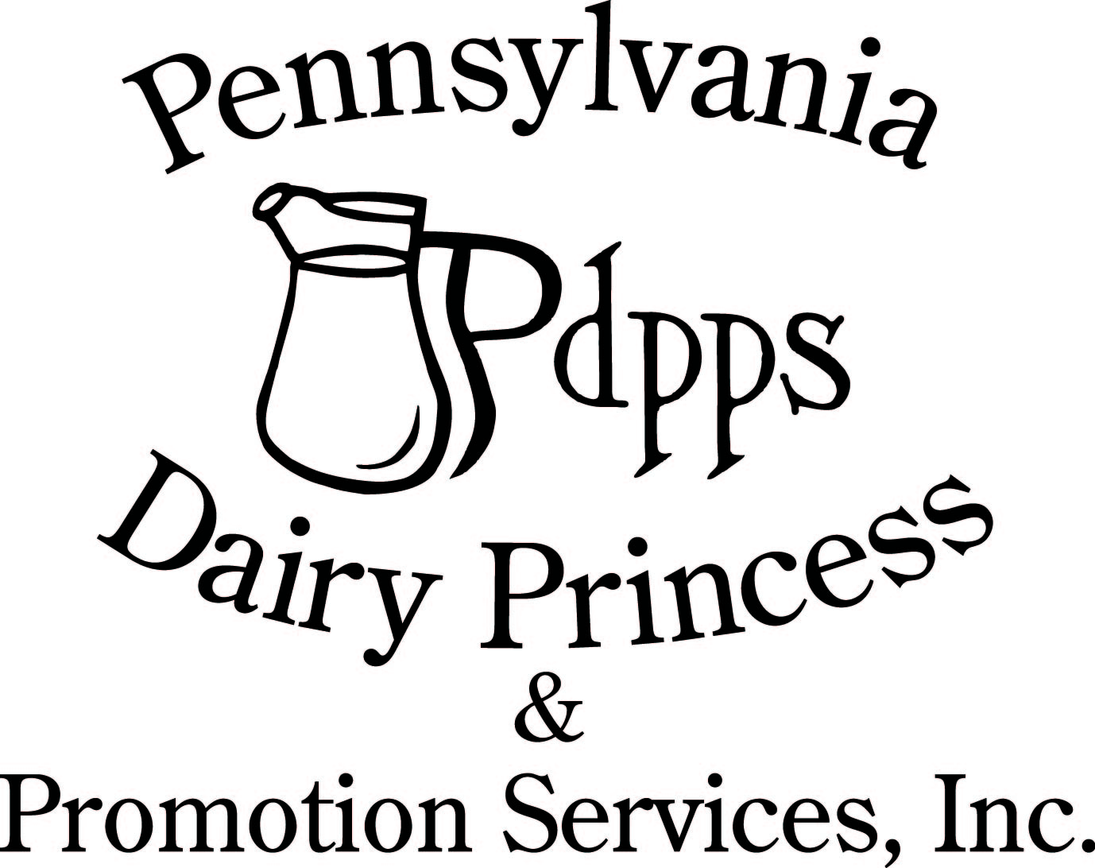
PO Box 177 Ph. (717) 599-4363
Laurelton PA 17835 www.padairy.org

***READ THIS LETTER CAREFULLY AND PLEASE SHARE IT WITH YOUR PARENTS. ***

Dear County Princesses and Parents:

State Competition is just a few short weeks away. I am certain each of you are busy preparing for the big day!

The PDPPS, Inc. board members, our Administrative Director Laura, and I are very excited to see each of you at State Competition. We are grateful for the opportunity to meet and get to know you at seminar and have been inspired with your dedication and passion for the dairy industry and the PDPPS program. Each of you has many attributes which qualify you to become a member of the State Royalty Team (SRT).

Pennsylvania Dairy Princess Competition activities will be held (Thursday-Saturday) September 19 – 21, 2024 at the Best Western Premier, 800 E Park Dr, Harrisburg PA. ALL county princesses are required to be present at ALL functions beginning Thursday through Saturday. The new 2024 – 2025 State Royalty Team must attend a 9:00 am brunch on Sunday, September 22, 2024, with a parent(s) or guardian(s) only. Please find attached a letter you may use, if needed, to excuse you from your school classes, activities and employment for attending the state competition.

Holding a state title involves many responsibilities, simultaneously giving you opportunities for a year of growth, enjoyable activities, and lifetime memories. The selected State Royalty Team will become the official spokesperson for the state’s dairy industry throughout 2024 into 2025. This team of three will be making many appearances on all days of the week, including Sundays. They will attend state functions, conventions, and seminars; as well as annual meetings and many appearances during the summer months of 2025 (ex: June Dairy month activities, Ag Progress Days). At times, the team will be required to work long days with a lot of standing and walking and participate in set-up and tear-down of displays. It will be a busy year of travel, new friendships, and dairy promotions. We will work with each member of the State Royalty Team to manage your events and previous commitments. You must be able to meet these expectations as a team member and commit a year of service to the Pennsylvania dairy industry. This is a year long internship opportunity.

You must submit your state competition questionnaire online no later than Sunday September 8, 2024 at:
https://form.jotform.com/padairy/2024-state-competition-princess-que. This is required regardless of your choice to compete for a state title. Please note, if you miss this deadline, the judges will not have the opportunity to review your application prior to competition. You will be instructed to handwrite an application at registration, and it will be marked as late.

If you do not want a state title or believe your personal commitments would not allow you to fulfill the duties of the Pennsylvania Dairy Princess or Pennsylvania Alternate Dairy Princesses, please notify the judges during your interview. You are still required to complete the online questionnaire, attend state competition and will be eligible to receive awards in the speech, presentation, scrapbook, poster display, radio spot, recipe contest and top seven categories.

PDPPS has committed to providing you lodging and meals for the competition weekend, along with a wide variety of fun activities and gifts. If you fail to attend, you and your county committee will be responsible for covering your cost (a minimum of $400.00). In addition, you risk losing your dairy princess title and you and your county may no longer be eligible to earn incentive awards.

Members Only Section
If you need copies of the handbook, dress code, or rules for any of the six in-person contests, log onto the Members Only section of the website to retrieve this information.

Website: www.padairy.org Password: fuelupwithdairy

Hotel Arrangements and Reservations

We have taken care of room reservations for each princess for Thursday, Friday, and Saturday evenings. Two county princesses will be assigned to each room. If you wish to go home on Saturday evening following the competition, you may do so. However, please advise us when you register if you plan to leave on Saturday evening. Meals will be provided for all princess contestants beginning Thursday lunch through the competition on Saturday. Meals are not provided for family members prior to the Saturday banquet. The Hospitality Room will be open to princesses throughout the weekend. Take time to enjoy refreshments, relax, and visit with the other princesses.

PDPPS, Inc. will not be responsible for other miscellaneous costs you may incur such as telephone, special TV arrangements, room service, etc. Any such charges must be settled at the main desk before your departure of the hotel. If there are any extra charges that have not been paid for before you leave the hotel, you will receive an invoice from PDPPS to cover the cost of the charges.

Parents and guardians must make their own reservations at :
Best Western Premier Hotel, 800 East Park Drive, Harrisburg PA
*For hotel lodging reservations, please call (717) 561-2800 (mention you are with the PA Dairy Princess Individual block) or click here: Best Western Lodging Link by August 22nd. The rate is $121.95 plus tax.

Attire and Dress Code

You will be asked to change immediately if your attire or appearance does not meet the dress code.

Suggested clothing for the activities is as follows:
Registration: Business Casual
Interview: Business (suit)
Presentation: Costume
Radio Spot: Business (suit)
Speech: Business (suit)
Thursday Lunch - Business (Judges will be present)
Thursday Evening Dinner - Business Casual (Pizza party and activities – Judges will be present)
Friday Breakfast & Knowledge Test: Business Casual (Judges will be present)
Friday Lunch- Business Casual (Judges will be present)
Friday Dinner & evening event: Business Dress/Suit and presentable comfy shoes (Judges will be present)
Saturday Breakfast: Business (suit) (Judges will be present)
Saturday competition practice: Business Casual (bring coronation shoes)
Professional Pictures, Luncheon, and Competition: Formal (gown)
New SRT Brunch: Business Casual

Please refer to the dress code descriptions in the PDPPS Handbook on Page 10.

You should pack your Thursday interview, skit presentation costume/items in a separate luggage bag. Hotel rooms are not guaranteed until 4:00pm. We will have a location for your luggage until your room is ready.

On Thursday evening, we will be checking all gowns and shoes to be sure they meet dress code requirements. If your dress does not meet the code, you will need to call a family member to bring another gown. Please wear comfortable shoes with your gown on Saturday. We suggest you avoid extremely high heels. No gloves or cowboy boots are to be worn at the coronation.

We also suggest you bring 2-3 dress pants and appropriate casual clothes (3-4) for your free/down time. Remember, we will be staying in a city hotel where dress is more formal than at home. Please remember to remove any piercings which are not in your ears to abide by piercing dress code and cover all visible tattoos.

Competition Contests

There are many activities during competition weekend with various contest opportunities. The judges will be selecting two presentations and two speeches to be presented during the competition on Saturday afternoon.

Between the seven (7) contests (speech, presentations, scrapbook, poster display, radio spot, knowledge test, and royal recipes) there will be 35 winners recognized and over $1,700 given away in scholarships! You can be recognized in multiple categories. Winners will receive a scholarship of $100.00, $75.00 for the runner-up, and $25.00 for the honorable mentions for the speeches, presentations, scrapbooks, poster displays, radio spots, knowledge test, and royal recipes.

Speeches
Speech topics should follow one of the 2024 prompts found in the PDPPS Handbook on Page 23. Please note these prompts are guidelines including the suggested audience. On check-in sheet, please note the appropriate audience for your speech prompt. Remember, your speech MUST respond to one of the 2024 Speech Topics and MUST be within the 3-5 minute time frame to qualify for a speech award.

We will have a podium with wired microphone and a lavalier microphone available. You may choose which of the two to use. If your speech is selected to be presented on-stage Saturday afternoon, you will need to change out of your gown into a suit to present your speech. A board member will be available if you need assistance.

Presentations
Remember, your presentation time MUST be within the 3-5 minute requirement to be considered for an outstanding presentation award. If your presentation is selected to be presented on stage during competition, you will need to change out of your gown into your costume. A board member will be available if you need assistance.

Display Board
The Display boards are required. We ask that you refer to page 19 for information concerning the contest.

Radio Spots & Scrapbook
30 – second Radio spot and Scrapbook are optional; we do encourage you to participate in both. Information concerning the scrapbook and radio spot contests are in the PDPPS Handbook.

Miss Congeniality
You, as county princesses, will be selecting Miss Congeniality from among your fellow princess class. This award will be announced and presented during the Saturday Coronation.
Schedule of Events

The PDPPS board members, Laura and I will be available during the competition for questions and support. The only events open to the public are the presentations on Thursday, speeches on Friday and the Saturday banquet and coronation. Other activities of competition weekend are for contestants only. The hotel front desk can supply suggestions on nearby points of interest or events if your family is looking for activities.

Thursday, September 19, 2024
Registration (Between 10:30 AM and 11:30 AM in the hotel lobby)
Please plan to arrive between 10:00 AM – 11:15 AM. If you find you will be arriving after 11:15 AM, notify Carrie at (814) 644-8814

You must turn in the following items at registration:
____ Completed Presentation/Speech Check-in form
____ Your sash (PDPPS will take it to be dry-cleaned, so please remove rosettes and pins)
____ Display Board
____ Scrapbook (optional)
____ Copy of 30-second radio spot (optional)
____ Confirm Luncheon Banquet Count

Thursday Lunch – September 19, 2024
State Royalty Team Greeting, Meet the Judges, & Introduction to competition
At 12:00 noon we will gather for lunch and an informal presentation by the State Royalty Team. I will review the expectations of the State Royalty Team. At this time, we can discuss any questions you may have at that time. Immediately following our lunch, we will begin interviews, presentations and you will be meeting with our emcee Kirk to discuss your formal stage introductions. At 7:00PM we will have a pizza party and social hour to reacquaint ourselves and visit with each other.

Interview
Each girl is allotted 7 minutes for their interview with the judges. There will be three main judges, male and female. When you arrive on Thursday, you will receive the interview schedule.

Presentations (Open for the public, parents and county committee members to attend)
Enclosed is the presentation schedule and is subject to minor changes. Please be sure to arrive at least 20 minutes ahead of your designated time. You are encouraged to watch your fellow princesses give their presentations in your free time between other activities. Remember to bring ALL the props which you will need for your presentation, so helpers are able to set up and remove it quickly. Please complete and submit the enclosed Contest Check-in Form and note if you require any type of “props” such as easels, table,
easel pad, etc.

Emcee Meeting
You will have an opportunity to meet with our coronation emcee, Kirk Sattazahn. Kirk enjoys meeting with each of the princesses, so he has an opportunity to get to know you better and use additional information you provide for your introduction at the banquet. This will be completed in between interviews and presentations.

Gown check
Following dinner, we will be checking your gown. After your gown is approved, you may return to your room for the evening.

Friday, September 20, 2024
Breakfast, Dairy Knowledge Test, Scrapbook, Speeches, Radio Spot
7:30AM we will meet for breakfast and begin promptly at 8:45 with the days scheduled competitions.

Dairy Promotion Knowledge Test
Everyone will complete the Dairy Promotion Knowledge Test. Remember to review and study Dave Lentz’s seminar presentation, the key message flip book that was given to you at seminar, our website, our checkoff programs websites, and tab 7of your seminar binder. There will be two proctors monitoring the test.

Radio Spots
At 10:00 AM, if you have decided to present a radio spot, you will meet with a separate panel of judges to present your radio spot in the afternoon as directed. Remember to make a copy of your radio spot for yourself because you are allowed to read directly from your script.

Speeches (Open to the public, parents and county committee members to attend)
Contestants will begin presenting speeches immediately following the Dairy Promotion Knowledge Test on Saturday. Each contestant will present a 3-5 minute speech responding to one of the 2024 speech topics.

Thank You Notes
You will be required to sign thank you notes for our program sponsors and donors during competition weekend. These thank you cards will be available for signing in the Hospitality Room at the hotel in between completing your contest.

Friday afternoon Activities
Prior to Friday evening dinner, we have a fun activity planned. Please wear/bring comfortable shoes and a business dress outfit. All princesses and judges will attend. Dinner and the evening activity are private and NOT open to parents, public or committee members.

Awards Dinner
During dinner, we will be recognizing the award winners in the following categories: Speech, Presentations, Scrapbook, Radio Spot, Poster Display, Royal Recipe and Dairy Promotion Knowledge. This is NOT open to parents, public or committee members. Directly after dinner, if you are a speech, presentation skit or radio spot winner, a board member will meet with you briefly.

Thank You Notes
For anyone who didn’t complete the thank you notes, you will have time to continue to complete them. These thank you cards will be available for signing in the Hospitality Room at the hotel in between completing your contest.

Saturday, September 21,2024
7:30AM Breakfast
Coronation Practice
Practice will be held Saturday morning in the ballroom following breakfast.
**You MUST bring your coronation shoes to practice.** Practice is private and NOT open to parents, public or committee members.

Pre-Coronation Preparations
We respectfully ask that your family, friends and loved ones refrain from sending flowers or gifts to you for at state competition. We understand you may have parents or friends who wish to help you prepare for coronation. Beginning at 9:45am, you may have one (1) FEMALE guest in your room to help you prepare. This may include helping with hair and/or makeup.

Photos
Individual photos will be taken Saturday 11:15am. You must be ready for all activities in your gown, crown and sash at that time. We will take photos of the contest winners at 11:45a.m. ALL contest winners MUST report to the photo area no later than 11:30a.m. The group photo will take place at 12:00 p.m. in the ballroom. This is NOT open to parents, public or committee members.

Banquet luncheon & Coronation
The banquet luncheon ticket table will open at 12:00pm on Saturday, September 21, 2024 with a ‘Mix and Mingle’ hour. The scrapbooks, posters, and PDPPS display boards will be on display. Doors will open at 12:30pm for the luncheon and will be served at 1:00pm in the ballroom. We will be hosting our first Benefit Auction at 2:00pm and the coronation begins at 2:30pm and should conclude by approximately 5:00pm.

Each county princess receives three complimentary banquet tickets, one for you and two for your parents/guests. We NEED to know the names of who is using your complimentary tickets. Please complete the enclosed reservation response card by September 1st.
Additional tickets may be purchased at $35.00 each (12 years old and over) or $15.00 each (3-11 years old) and may be ordered by completing the enclosed response card with a check to the above address. Tickets may also be purchased online at our Dairy E-Store, www.padairy.org. All tickets will be held at the door/ticket table.
Please check with your committee, family and friends to purchase tickets before deadline. Each table, at the banquet, seats ten people. Additional guests will be assigned seats at nearby tables.
Please note the September 1st ticket deadline, no changes will be made after Tuesday, September 10th.

Guests may come after the luncheon between 1:50 and 2:30 pm to participate in the auction and watch the coronation. Seating will be available at the back of the room. Guests can enter once the meal has concluded. We also request there be no private videos taken during the competition. We will provide an opportunity for you to download a professional recording.

We are happy to share, live streaming will be available again this year, so loved ones may also view the coronation. Please go to PDPPS Facebook page (https://www.facebook.com/PDPPS) at 2:30 p.m. for the live stream.

Post-Coronation Photos
Any princess in the Top Seven, Miss Congeniality, the new State Royalty Team and their family must remain for photos immediately following the competition. (*Please note that photos may take considerable time).

New State Royalty
The newly selected Pennsylvania Dairy Princess and Alternates will need to remain in Harrisburg until Sunday, September 22nd for brunch at 9:00am. At this time, the new State Royalty Team and their parents will receive more details on schedules and duties of the state royalty from and the board. There will be a State Royalty Code of Conduct and a list of expectations for you to review and sign. Dress for this event is business casual. Typically, this brunch concludes around 12:00pm.

State Royalty Scholarships
Awards and scholarships for this year are again made possible by donations from several donors. The Pennsylvania Dairy Princess will receive a $2,000.00 scholarship and the Alternates will each receive a $1,000.00 scholarship. We encourage these awards to go toward your savings for college or other educational endeavors. The State Royalty team’s travel, lodging and meal expenses will be covered during their reign and each team member will receive a clothing allowance for the purpose of professional attire for their upcoming reign.

Most importantly, please remember that each of you should be proud of the commitment you have made to the dairy industry and promoting as princesses for the year. We want you to have an enjoyable time and take-home good memories, new experiences and renewed friendships. Some of you will have additional responsibilities as you represent the dairy industry on the state level, but all of you will continue to fulfill the important role of dairy promotion for which you were chosen at your county competition.

If you have any further questions, please don’t hesitate to contact your board member, Laura or myself. We are looking forward to seeing you Thursday, Sept. 19th . The PDPPS, Inc. board members, Laura and I wish all of you the best of luck!

Sincerely,
Carrie M Anderson
Program Director
Pennsylvania Dairy Princess & Promotion Services, Inc.
(814) 644-8814

CC: County Chairperson (Letter and Invitation only), PDPPS Board Members

Enclosed: Letter of Excusal, Invitation, Response Card, Contest Check-in Preparation Form, Speech Schedule, Presentation Schedule, Guidelines

