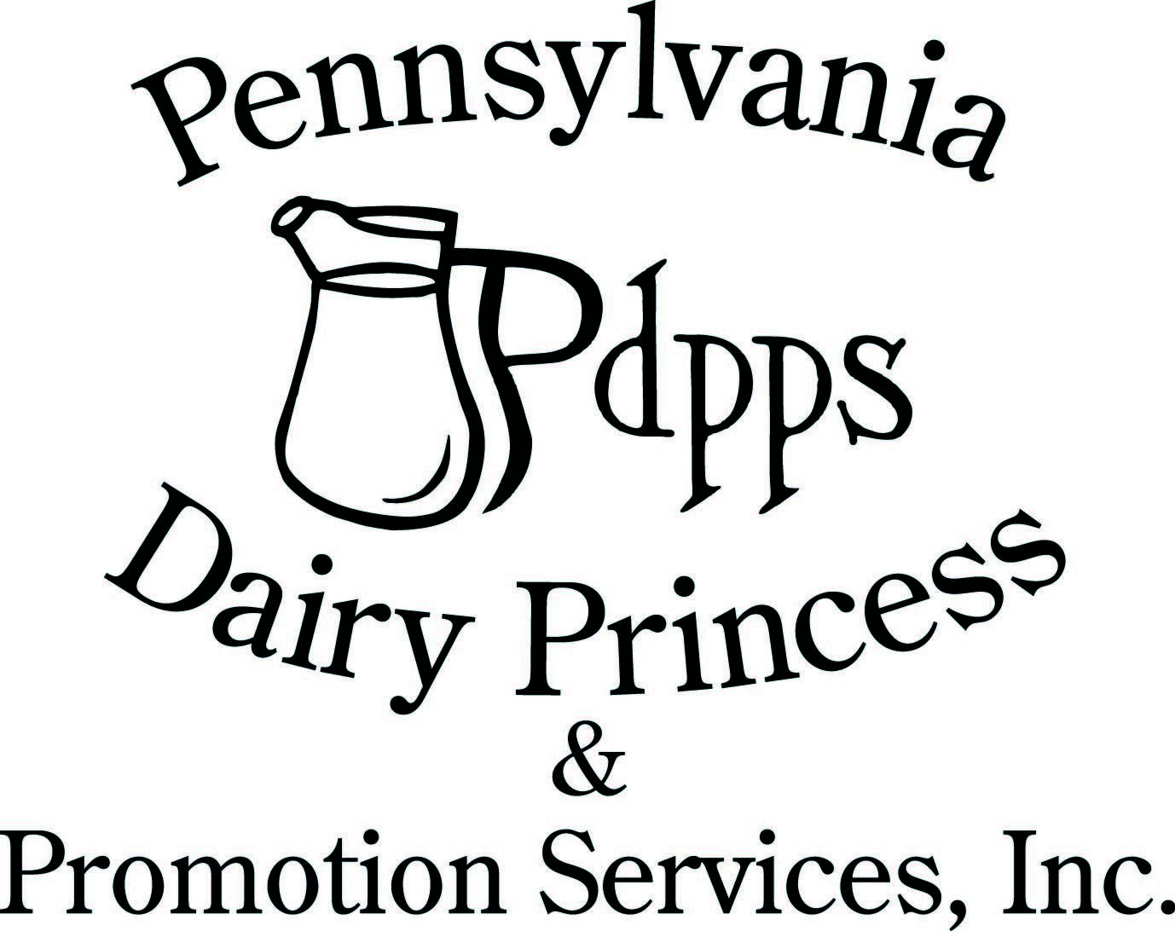
PO Box 177 Ph. (717) 599-4363

Laurelton PA 17835 www.padairy.org

March 7, 2024

Dear County Dairy Promotion Chairperson and Committees,

Greetings from PDPPS! As spring approaches, so does preparation for a new year in Dairy Promotion and we have an exciting year planned! Please take time to read this letter closely as there are many important dates and information included. Let’s start with training and leadership opportunities, all links for training are found at the bottom of this letter.

We will begin by hosting a virtual Spring Kickoff Meeting on March 16th from 10:00am to 12:00pm. You will need to register to attend. There will be two mini-seminar training sessions. One for Western PA (June 18) in Franklin and one for Eastern PA (June 19) in Middleburg. If there are royalty unable to attend, email your regional board members to let them know the names for excused board approval.

Our Dairy Princess Training Seminar will begin on Tuesday afternoon, July 9th at Roxbury Holiness Camp, Roxbury, PA and will conclude on the afternoon of Friday July 12th. There is a required $20.00 non-refundable deposit per attendee for the Dairy Princess Seminar. All other expenses for each princess/alternate and one chaperone will be covered. The 2024 State Competition will be at the Best Western Premier in Harrisburg from September 19th-21st. Our banquet luncheon & coronation will start at 1:00pm on Saturday. Links and information to come later.

For your convenience, we have highlighted in yellow the major changes in the 2024 Pennsylvania Dairy Princess Handbook. Minor updates in the 2024 handbook include changes to State Competition requirements, Incentive policy changes and Word format Incentive reports will be accepted.

Each county chairperson received one copy. A gentle reminder to check out pages 37-41 for an additional $50.00 each month through Allied Milk Producers.

All Sash and Crown Orders with payment are due March 30 and no later than May 1st. When your Sash and Crown orders are mailed, you will receive a packet of information for the County Chairperson for Seminar and Competition. There will be a packet sent directly to the County Princess after they are crowned with the information about Seminar and Competition.

PDPPS has a policy that only counties that have submitted an up-to-date roster will receive incentive money. Please be sure to complete the committee list form with all committee individuals including all royalty parents. You will need to complete a “new form” for each committee member. A link for the contact form is located below.

You will receive an e-mail with a copy of the submitted application. If the individual doesn’t receive a confirmation screen and an e-mail, the application WAS NOT submitted properly. All Princess applications will require three dairy recipes in Word or txt format only. These recipes will be used in the annual recipe book. As a county, if you would like to have a record of applications, you will need to ask your Princesses and Junior Royalty to print a copy for your records.

All princesses and junior royalty must complete the entire online application including medical information and handbook, photo release and dress code release section by June 1.

Online applications can be found at:

Web address: www.padairy.org - members only password fuelupwithdairy

Princesses:

https://form.jotform.com/padairy/2024-dairy-princess-application

Alternates:

https://form.jotform.com/padairy/2024-alternateDPapp

Junior Representatives:

https://form.jotform.com/padairy/2024-junior-promoter

It is your responsibility to read, print (if needed), and complete all required documents.

Forms/Online Forms to Return:

- Virtual Spring Kickoff Meeting Registration
  - https://us02web.zoom.us/meeting/register/tZIqdOyorDIrHtZVYKcAcwEovzPesizh80U4

- County Coronation no later than April 30, 2024
  - https://form.jotform.com/padairy/2024-county-pageant-information

- Sash & Crown Orders (enclosed or on member’s only) No later than: March 30/May 1, 2024

- Volunteer Recognition Nominations No later than: April 1, 2024 (in handbook)

- Committee Contact Information No later than: May 15, 2024
  - https://form.jotform.com/padairy/2024-county-committee-contact-list

- County Royalty Team Listing No later than: May 31, 2024
  - https://form.jotform.com/padairy/2024-county-royalty-form

- County Seminar Reservation No later than: May 31, 2024
  - https://form.jotform.com/padairy/2024-county-seminar-reservation-for

- Seminar Adult Attendee RSVP No later than: May 31, 2024
  - https://form.jotform.com/padairy/2024-seminaradult-attendee-rsvp

- Mini-Seminar Attendee Training Reservations No later than: May 31, 2024

Must complete one registration for EACH attendee (including ALL adults)
  - https://form.jotform.com/padairy/2024-mini-seminar-registration

On behalf of all of us at PDPPS, thank you for your time and dedication to the dairy industry and helping to develop future leaders. As always, please let us know if we can help you or if you have suggestions to help with your programming.

All the best,

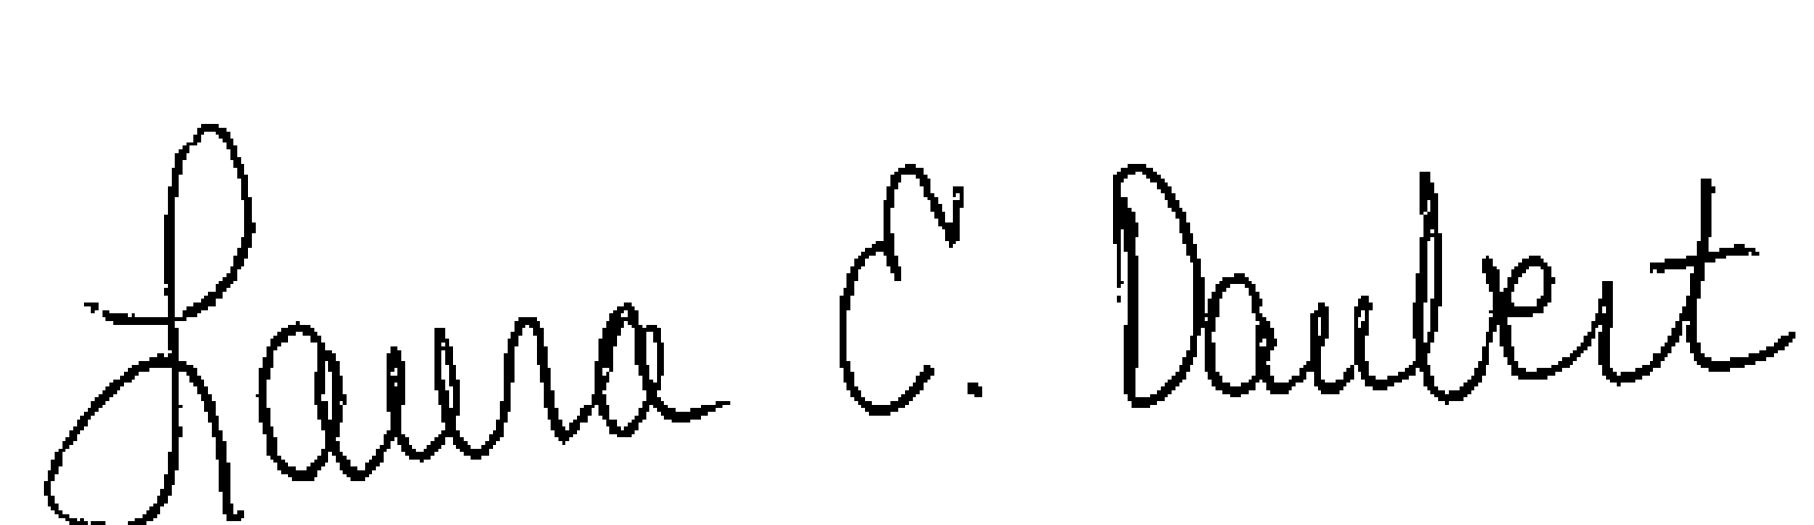

Laura E. Daubert Carrie M. Anderson

PDPPS Administrative Director PDPPS Program Director

