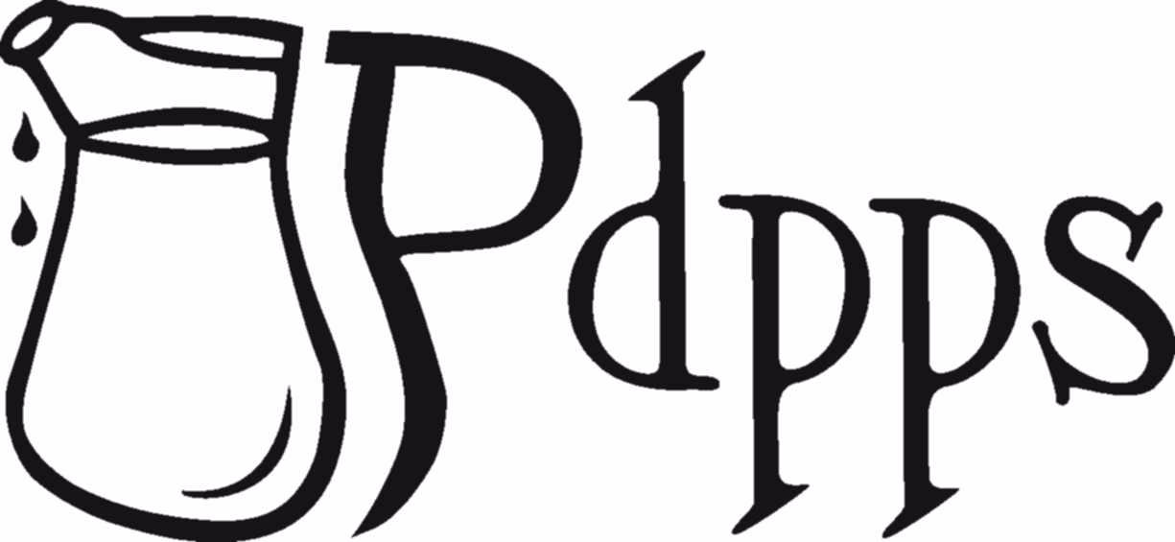
Pennsylvania Dairy Princess & Promotion Services, Inc.

PA Dairy Princess Training Seminar July 11– 14, 2023 Check-in Sheets (2 pages)

Speech Check-in Sheet
Please bring this form with you to check-in on Tuesday, July 11, 2023.

Name: ____________________________ County: _____________________________

Circle One: Princess Alternate

Speech Information:

My speech title is: ___________________________________________________________________

My speech answers the speech prompt number: ___________ (from the speech section in the handbook)

My speech target audience: ______________________

Pennsylvania Dairy Princess & Promotion Services, Inc.

Name: ____________________________ County: _____________________________

Circle One: Princess Alternate

Presentation Information Check-in Sheet:
Please bring this form with you to check-in on Tuesday, July 11, 2023.

On the bottom of this form, draw the set up of your presentation.

Presentation title: _______________________________________________________

Circle the age group your presentation is geared for:

- Preschool & Kindergarten
- Grades 1-2
- Grades 3-5
- Grades 6-8
- Grades 9-12

Do you need to change into a costume for your presentation? Yes No

Setup Requirements (i.e. Easel, table, etc.): ___________________________________________________________
__________________________________________________________________________
__________________________________________________________________________

