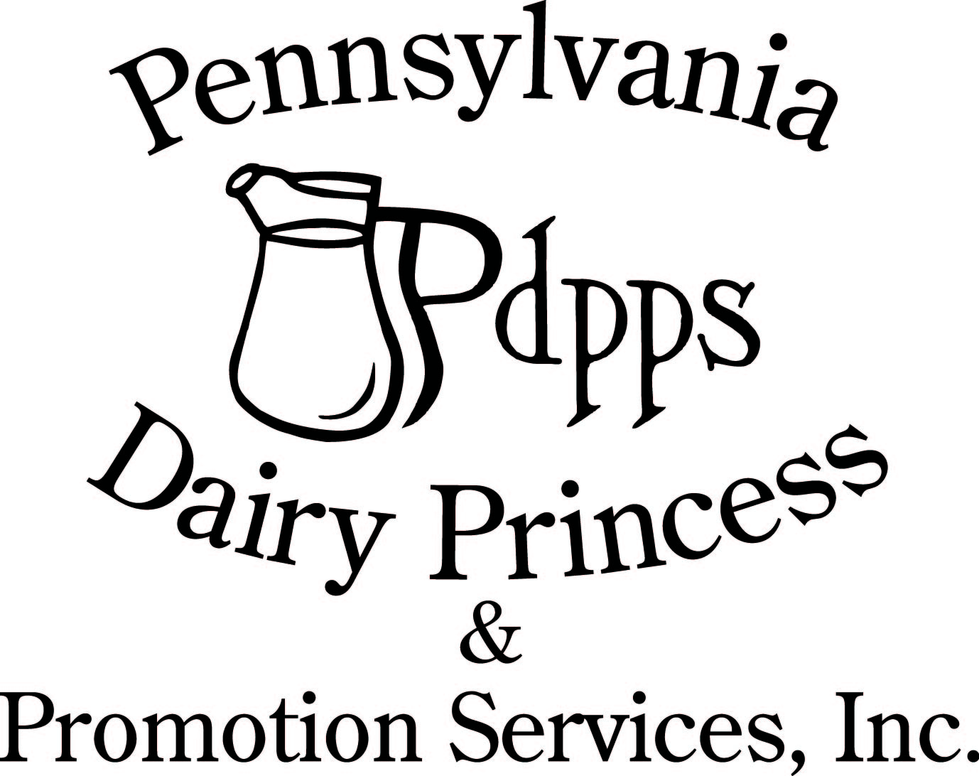
PO Box 177 Ph. (717) 599-4363
Laurelton PA 17835 www.padairy.org

2023-2024 TINA M. SHULTZ MEMORIAL SCHOLARSHIP AWARD
Deadline: June 20, 2024

The Pennsylvania Dairy Princess & Promotion Services, Inc. is offering a $500.00 scholarship, through the Tina M. Shultz Memorial, for any 2023-2024 County Dairy Princess who has reached second level incentive for the year. Please complete the following application and submit by June 20, 2024.

Tina Marie Shultz was a member of the 1985-1986 class of county dairy princesses. Selected to serve as Huntingdon County’s Dairy Princess in June of 1985, she did an outstanding job of promoting the dairy industry and its products under extremely difficult personal complications. Three months before her county pageant she lost her left leg to cancer and throughout her reign she battled the insidious disease. Except when she was hospitalized, Tina seldom missed an engagement or opportunity to promote. In 1986, this award fund was created in her honor.

Scholarship Guidelines:
- Must be a recent retired 2023-2024 County Dairy Princess
- County must have reached second level incentive
- Submit two (2) letters of recommendation. Each letter must be in a PDF form and be submitted with the application.

Application must be postmarked to PDPPS Office by June 20, 2024.
PDPPS
Laura Daubert
PO Box 177
Laurelton, PA 17835

or emailed to laura@padairy.org by June 20, 2024 with the subject: Your Name, 2023-24 Shultz Application

The applications are judged by a panel not affiliated with PA Dairy Princess and Promotion Services, Inc.

This page is intentionally left blank.

2023-2024 TINA M. SHULTZ MEMORIAL SCHOLARSHIP
Deadline: June 20, 2024

Applicant Full Name: ______________________________ Phone Number: ________________________

Address: _____________________________________________ City: ____________________________

Zipcode: _______________ Age: ________ GPA: _____________

Parent(s) Names: _________________________________________________________

Parent Signature: ______________________________________________________________________

College Attending (if applicable): ________________________________________________________

Please list your activities below:

FFA and/or 4-H Involvement/Awards/Degrees:

Extra-Curricular Activities:

Community Involvement:

Awards or Honors:

In what way has serving as Dairy Princess this past year been the most impactful or influential in your life?

Serving as Dairy Princess this past year, what was the most difficult or challenging hurdle that you had to overcome?

Applicants Signature: _________________________________________ Date: ________________

Please enclose/attach your two letters of recommendation with your application.

